ADEYEMI FOLASHADE

Adeyemi.folashade.womentechsters.org

Assignment submission

28-05-2021

1. Step 1 deploy a windows server 2019 Gen 1 remotely from Azure cloud- named mine shade VPN

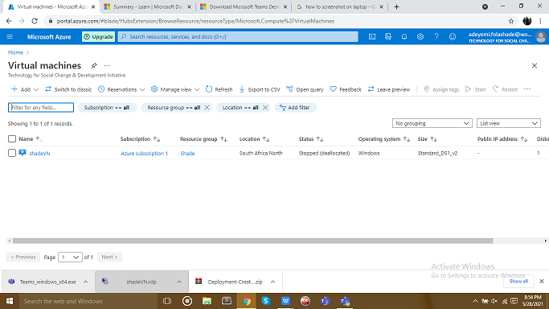

Step 2 Creating virtual window machine

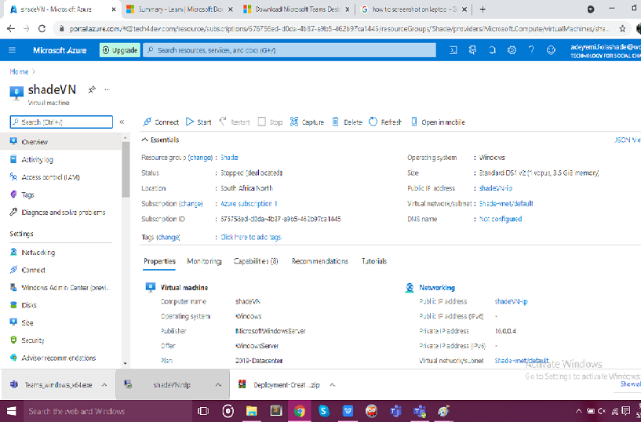

Step 3 Install the Azure server management tools and services

Created management group ID Cyberspace, display name cyberpractical

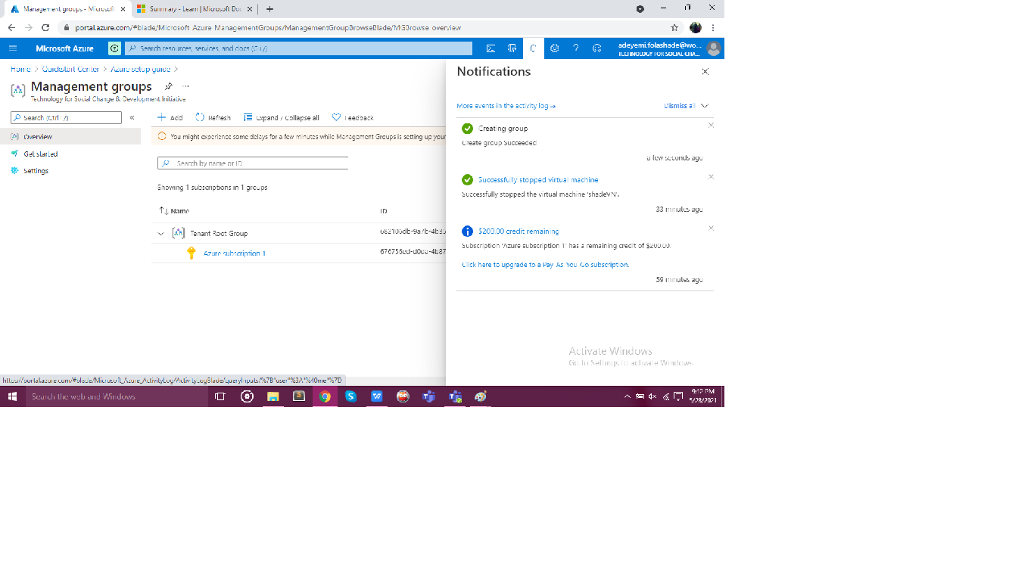

Step 4 Added Subscription to Management group created.

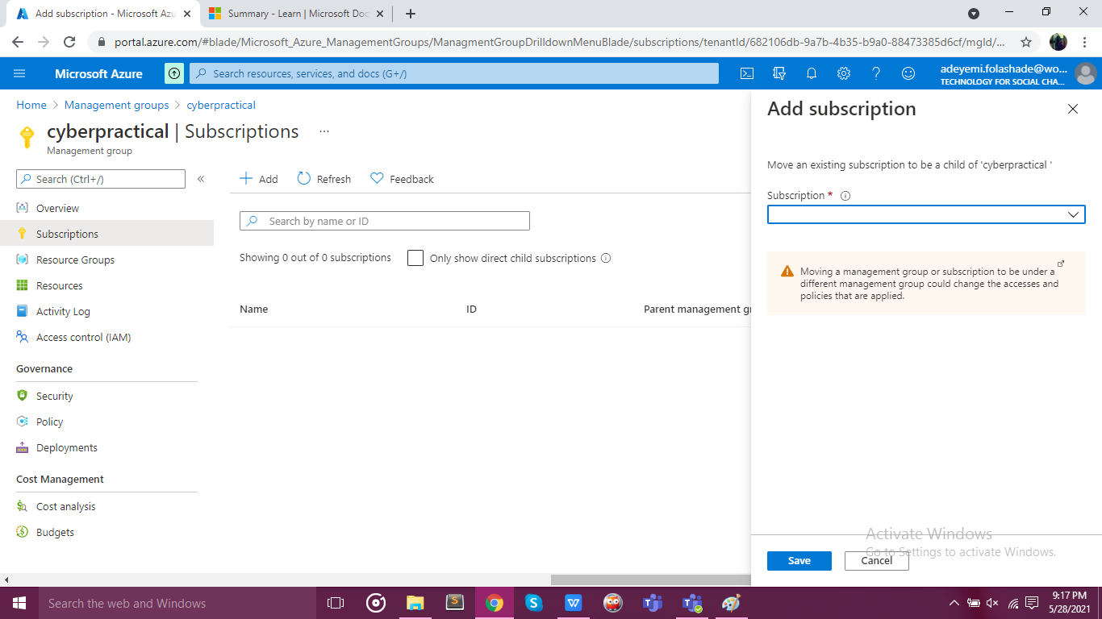

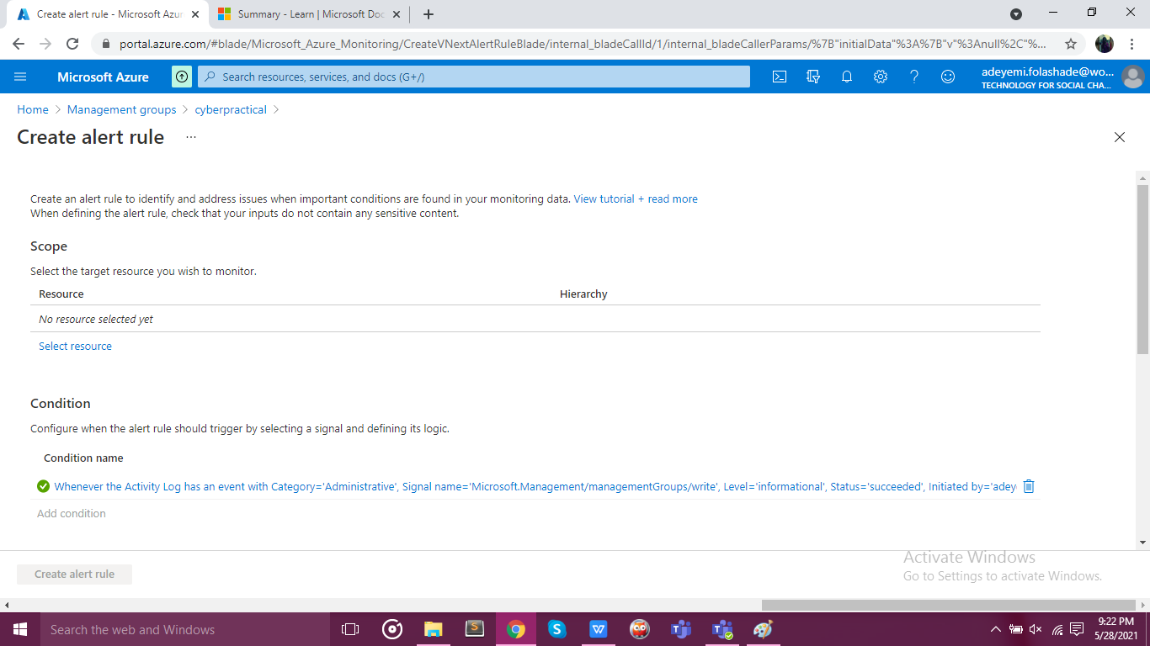

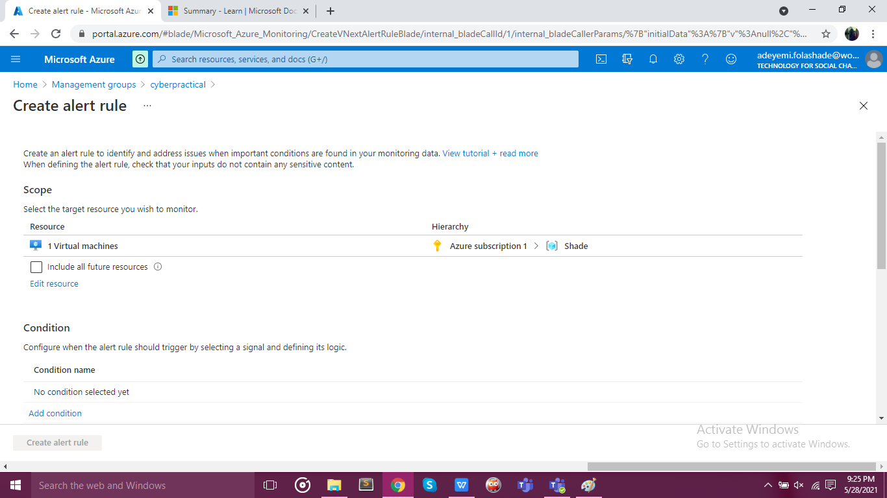

Step 6 confirming my windows vm is linked to the Management and resource group

